Password Policy
This SOP outlines the password policy for Store Managers (SM) in order to maintain secure access to the system. It provides instructions for setting, changing, and managing passwords, ensuring that they meet specific security requirements.
Process Overview:
The password policy for Store Managers (SM) is designed to enhance the security of access to the system. It covers password creation, changes, and management. Here are the step-by-step instructions:
- Initial Login:
Step 1: Access the Email:
- Start by opening your email client.
Step 2: Select a Relevant Email:
- Choose an email that contains your username and initial password.
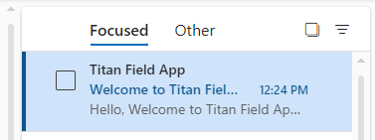
Step3: Click on Login Link:
- In the selected email, click on the provided login link. This link directs you to the login page.
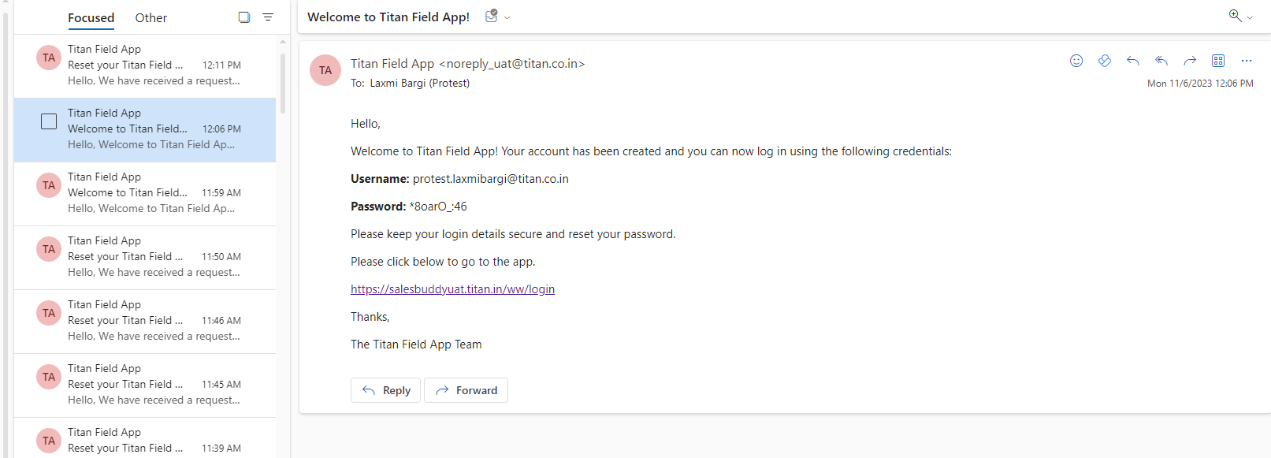
Click here
Username and initial password
Step 4: Enter Email and Initial Password:
- Enter your email ID and the initial password sent to your registered email. (Note: The initial password must be changed after the first login.)
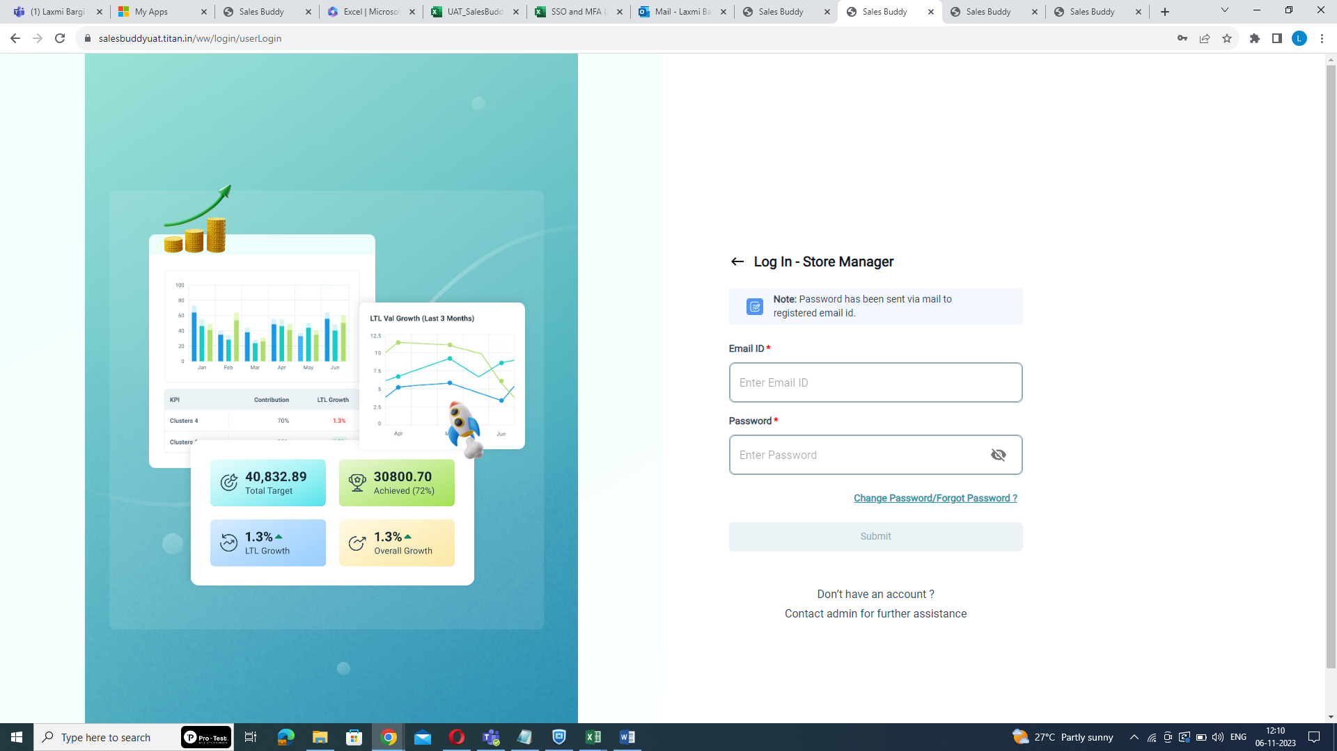
Enter email ID and initial password
Step5: Click Submit:
- After entering the initial password, click "Submit." The system will redirect you to the password reset page.
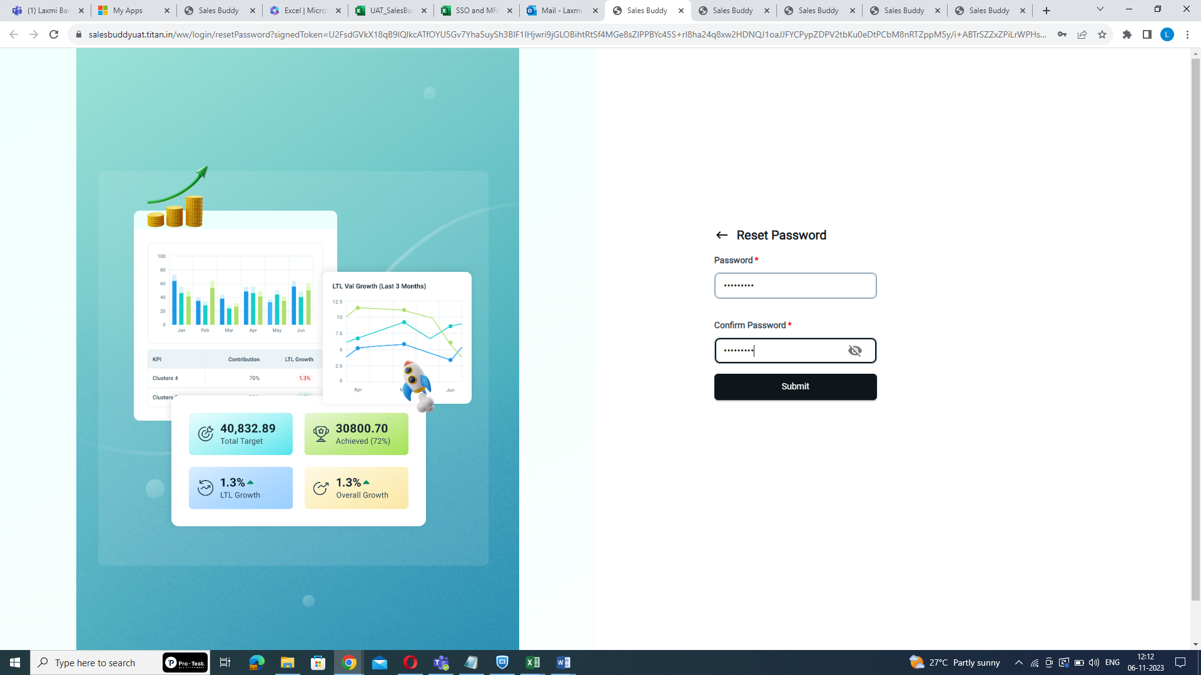
Click submit
Step6: Reset the Password:
- On the reset password page, create a new password. Ensure that it meets the following criteria:
- Password length must be at least 8 characters.
- At least 1 digit.
- At least 1 lowercase letter.
- At least 1 uppercase letter.
- At least 1 non-alphanumeric special character.
Enter password
Step7: Confirm the Password:
- Re-enter the newly created password for confirmation.
Re-enter the password
Step8: Click Submit:
- Click "Submit" to confirm the new password.
Click submit
Step9: Click on Here:
- To go back to the login page click “here”. It will redirect you to the login page.
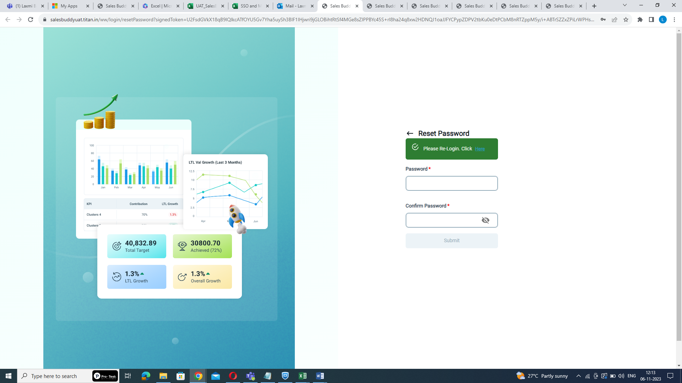
Click here
Step9: Re-Login:
- Re-login using your email ID and the newly created password.
Enter email ID and password
Step 8: Click submit:
- Click "Submit" to login. Now you will be required to enroll in the Multi-Factor Authentication (MFA) process
Note: After 5 unsuccessful login attempts, the account will be locked for 15 minutes.
- Change Password or Forget Password
Step1: Click Change Password/Forget Password?:
- If you want to change your password or have forgotten it, Access the login page and click "Change Password/Forget Password?".
Click here
Step2: Enter Email ID:
- Enter your email ID on the provided page.
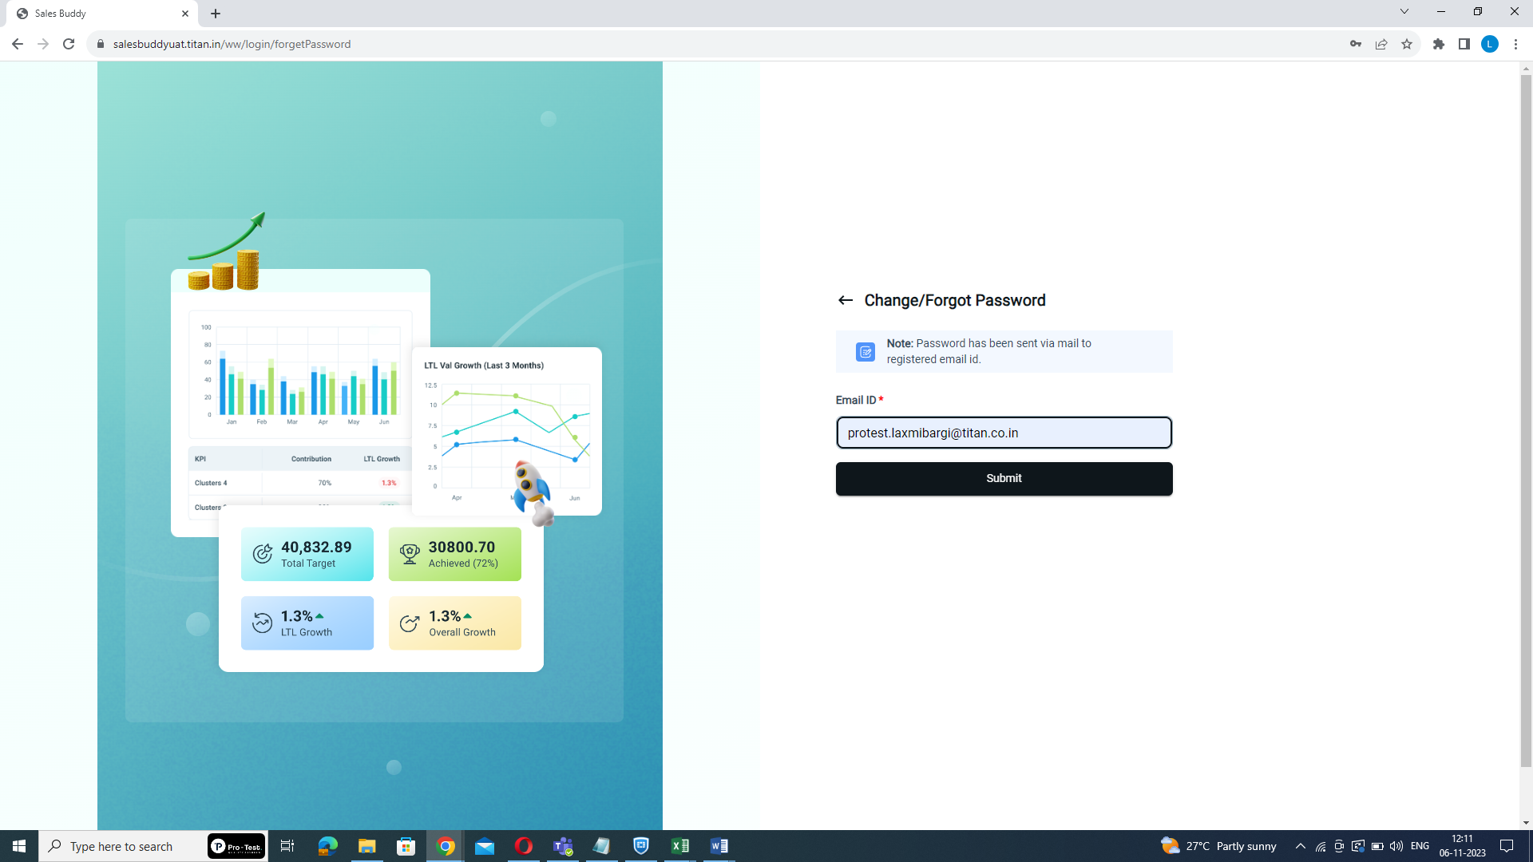
Enter email-id here
Step3: Click Submit:
- Click "Submit". A reset password link will be sent to your registered email.
Click submit
Step4: Access the Email:
- Go to your email and select the relevant email containing the reset password link.
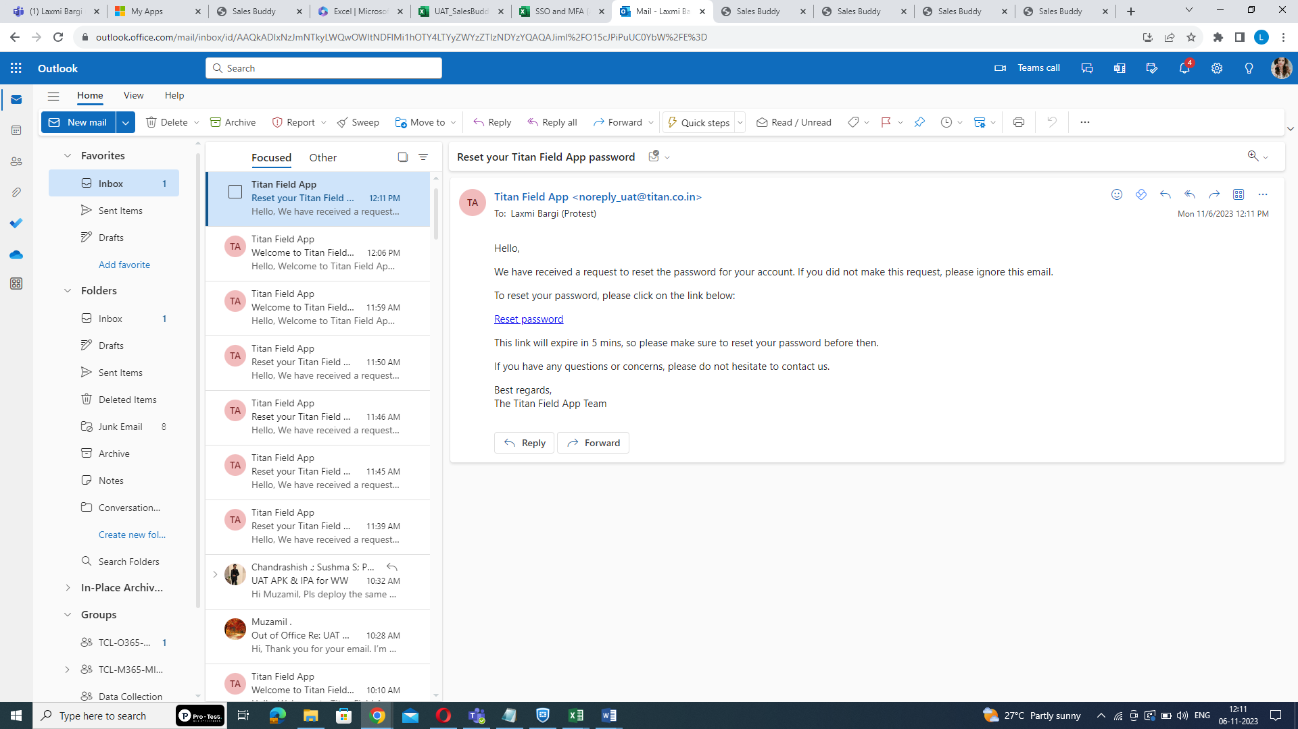
Step5: Click on Reset Password Link:
- Click on the provided reset password link. You will be redirected to the password reset page.
Click here
Step6: Reset the Password:
- On the reset password page, create a new password. Ensure that it meets the following criteria:
- Password length must be at least 8 characters.
- At least 1 digit.
- At least 1 lowercase letter.
- At least 1 uppercase letter.
- At least 1 non-alphanumeric special character.
Enter password
Step7: Confirm the Password:
- Re-enter the newly created password for confirmation.
Re-enter the password
Step8: Click Submit:
- Click "Submit" to confirm the new password.
Click submit
Step9: Click on Here:
- To go back to the login page click “here”. It will redirect you to the login page.
Click here
Step9: Re-Login:
- Re-login using your email ID and the newly created password.
Enter email ID and password
Step 8: Click submit:
- Click "Submit" to login. Now you will be required to enroll in the Multi-Factor Authentication (MFA) process
Note: After 5 unsuccessful login attempts, the account will be locked for 15 minutes.

- Password Expiry:
Change Password Every 60 Days:
- Be aware that the system will automatically notify you to change your password after 60 days. This is an important security measure.
By following these step-by-step instructions, Store Managers can ensure their passwords meet the security requirements and maintain a secure access policy in accordance with the organization's guidelines.

